

# Reinforcing Minority Racial Stereotypes: The Role of Lateral Surveillance in Singapore

by

Chen Shuyi A0239953N

Ng Jong Ray, Edward A0216695U

Xu Erika A0290404M

**Group D3**

**Tutorial: D3, 10:00 to 12:00pm, Thursday**

**Tutor: Rachyl Lim Rui Qi**

**Submission Date: 17th March 2024**

# Introduction

Singapore’s narrative always deemed itself as a well-regulated multiracial society–one that celebrates racial harmony and racial equity. Within academic and political discourse, Singapore’s government is commonly described as a “benevolent dictatorship,” by which the government makes decisions for and in the interest of the people (Tan, 2015). Heavy surveillance is a reflection of such governance. Because surveillance is seen as the solution for preventing the recurrence of unwanted situations, surveillance is often implemented as a safety precaution to protect Singapore’s citizens. The concept of surveillance is well-accepted by the Singaporean population as they trust their government's decisions in trying to protect them (Kamaludeen, 2018). This positive perception of surveillance extended to lateral surveillance, where citizens themselves integrate surveillance methods into their daily lives. The high prevalence of lateral surveillance exists within Singapore, particularly in public domains such as the Mass Rapid Transit (MRT), buses, and other public spaces. This exemplifies a shaming culture that is used as a deterrent to social deviance (Jiow & Morales, 2015). Thus, lateral surveillance functions to regulate behavior and maintain societal order as people behave more appropriately in fear of being reported and socially ridiculed.

While much of the literature on lateral surveillance discusses its occurrence and effectiveness, the existing acts of lateral surveillance and its impact on society are left unexamined. In particular, there is a gap in how the intersection of race and racialized attitudes shape and influence surveillance. Despite the prevalence of Singapore’s narratives of multiracial harmony, racial discrimination and attitudes exist in the lives of everyday people (Puthucheary,

2019). Therefore, crime and deviance cannot be understood without the analysis of race. The current population consists of 74% Chinese, 13% Malays, 9% Indians, and 4% others

(Anonymous, 2023). Common within the discourse of Singaporeans are negative stereotypes of

Malays and Indians, which include being lazy, ineffective, and financially deprived (Velayutham, 2016). On the other hand, the Chinese were viewed in a much positive light as “culturally superior and being the numerical majority” that dominates the political, economic, and social sphere in Singapore (Velayutham, 2016, p.464).

Since racial stereotypes are ‘reflexive and exaggerated’ mental images that we hold of individuals of a specific racial group, these stereotypes are so inflexible that we often disregard any information that contradicts the existing stereotype about that racial group (Anonymous, 2023). We believe these stereotypes also manifest in the act of lateral surveillance whereby deviant behaviors are being viewed through these racial stereotypical lenses. Thus, this paper aims to analyze how existing acts of lateral surveillance and public moral criticism reinforce and reproduce harmful racial stereotypes of minorities in Singapore.

This paper first reviews the current literature regarding lateral surveillance and its application in Singapore. Secondly, we investigate the historical root of multiracialism and racial stereotypes, thereby assessing the implications of these stereotypes. From there, we proceed to the methodology section and analyze our selected case study. Lastly, we draw connections from our findings to the relevant theories and highlight the sociological significance of our study.

**Literature review**

# Lateral Surveillance and Singapore

Lateral Surveillance can be described as “peer-to-peer monitoring, understood as the use of surveillance tools by individuals, rather than by agents of institutions public or private, to keep track of one another” (Andrejevic, 2002, p.488). This description highlights how surveillance has shifted from people working for the authority to everyday individuals who have no relation to the institutions conducting this surveillance. Lateral surveillance should not be just characterized by the paranoia of being watched all the time, but also by “the paranoia that serves as an alibi for being always on the lookout, always watching” to catch others in the act of deviance (Andrejevic, p.488). Every individual plays both roles, being the surveillant and the surveilled simultaneously, seamlessly transitioning between them depending on the situation. This new power relation can be described as one that flattened the conventional understanding of the vertical hierarchical power structure of surveillance (Albrechtslund, 2008), by which only the surveillant holds the power to watch while the surveilled is the passive subject of control. This decentralized nature of surveillance allows everyday individuals to monitor and observe each other in various social contexts.

In their study of lateral surveillance in Singapore, Hee Jhee Jiow and Sofia Morales (2015) illustrate how the phenomenon is manifested through the sharing of video clips and images on social media platforms and online forums. They note that many respondents express concerns about the potential publicization of surveillance footage through prominent media channels in Singapore, with Straits Times Online Mobile Print (STOMP), a citizen journalism site, being particularly feared (Jiow & Morales, 2015, p.336). Their research also provides evidence that most Singaporeans believe they are under constant surveillance and argue that this form of surveillance directly impacts social behaviors (Jiow & Morales, p.336). While the research primarily focused on measuring disciplinary power through the changes in public behavior, more exploration can be done on the consequences of lateral surveillance.

Disciplinary power can help explain why individuals under lateral surveillance, out of fear of being perceived as deviant, conform to social norms. Jiow and Morales attribute this disciplinary power to the strong shaming culture in Singapore. Public shaming can be defined as

“a practice of public moral criticism in response to violations of social norms” (Billingham & Parr, 2020, p.998), and has an expressive role “to affirm morally authoritative social norms publicly” (Billingham & Parr, p.1000). Hence, public moral criticism or the act of public shaming is a function of reaffirming social norms, where at the expense of the deviant, moral markers are reaffirmed through public shaming. Surveillance footage shared online can be considered an act of public shaming, as the surveilled “deviant” act is now available for the public to see. Furthermore, online platforms such as STOMP include a comments section, where online users can leave their opinions and discuss with others publicly. The comments section serves as a site for public moral criticism as online users are able to condemn the deviant act and go as far as to condemn the deviant individual. Importantly, online users only have a limited context of the video; thus, shaming the deviant usually comes in the form of attacks on the deviant’s appearance as seen later in the case study.

# Multiracialism: Racial Stereotypes in Singapore

To examine lateral surveillance in Singapore, a deeper understanding of its racial history and narratives is essential. Singapore’s multiracialism can be traced back to British colonial states and open trading in the early 19th century which attracted a large number of immigrants from China, Southeast Asian countries, and British India. As a result, Singapore was and is a “descendant of immigrants” (Vasu, 2007, p.52). Despite having people from diverse racial groups, Singapore’s colonial society was still regarded as a “highly segregated” one (Velayutham, 2016 p.457). Citizens of the same race lived together within their own social borders, maintaining and protecting their racial-cultural identities and interacting with people of different races primarily for economic purposes (Velayutham, 2016).

After Singapore gained independence in 1965 from Malaysia, the state inherited this racial division, while also attempting to implement multiracialism as the state ideology. The Chinese-Malay-Indian-Others (CMIO) model, which categorizes citizens into four ethnic groups, was adopted as the administrative mechanism for managing and regulating racial policies (Kathiravelu, 2021). The Singapore government also placed great emphasis on ensuring racial harmony by punishing individuals who demonstrate racially discriminatory language and behaviors through legal sanctions (Chong & Zaini, 2022).

Despite the government's efforts to prevent racial discrimination and biases, they are still prevalent in Singapore society. A study conducted by the Institute of Policy Studies (IPS) in 2014 highlighted the prevalence of racial stereotypes in Singapore society (Mathews, 2014). IPS surveyed *Indicators of Racial and Religious Harmony* and one of the questions is as follows: ‘When I know what a person’s race is, I have a good idea of what some of their behavior and views are like.’

The result yielded significant findings. Among the 4131 participants, 46% agreed or strongly agreed with the statement, and 35.6% somewhat agreed (Mathews, p.55), indicating about 80% of the population have pre-existing perceptions towards people of certain races. This finding highlighted the prevalence of racial stereotypes within Singapore and how easily individuals can be subject to them in their everyday interactions with people of different races. Therefore, social norms in Singapore society are embedded and intertwined with elements of racism.

This racialization of lateral surveillance is a process that starts from an individual capturing an act of deviance on their personal device to then publishing that online, allowing other online users to publicly shame the deviant. Since this process can happen without the original surveillant’s intention of racializing the deviant act itself, the consequence of lateral surveillance is the reinforcing of current Singaporean racial norms and stereotypes.

# Methodology

For this project, we aim to use observational research and content analysis to gain a better understanding of how the practice of lateral surveillance reinforces and internalizes harmful stereotypes of ethnic minorities in Singapore.

As previously discussed, the phenomenon of lateral surveillance is manifested through the dissemination of recorded instances of deviant behavior on social media platforms or news articles, often as sensationalized posts to attract more online viewers. Moreover, the comment section of these online platforms allows people to express opinions and also serves as a window into public reactions. Therefore, our group will analyze both the content of the surveillance footage as well as comments made by other users to understand the consequences of lateral surveillance and how it perpetuates racial stereotypes of minorities through captured acts of deviance.

We have chosen to look at the popular citizen journalism site STOMP Singapore, as well as the popular digital news media Mothership. STOMP hosts user-generated articles for the public to see (STOMP, 2009). Mothership is a digital new media site that focuses on a variety of topics from news to user submitted stories for them to cover (Mothership, n.d.). Both these popular online sites have extremely high viewership and user participation in the form of the comments section. Relevant articles will be defined as posts with content that is by an individual capturing other individual(s) committing a deviant act. Moreover, these posts should have a relatively high viewership as well as a comment count of at least 50 to ensure that a wide range of reactions can be captured.

In our attempt to systematically find relevant articles for analysis, we decided to utilize the latest article feature found on both sites to find recent articles based on the date of their posting. We have set the duration of this search to start from December 2023 till February 2024.

We also used keyword searches based on the CMIO model, such as “Chinese,” “Indian,” and “Malay,” to find specific articles related to race. For each article found, we aim to identify if the post has any racial bias and or if the comments have any race-related opinions about either the deviant or the deviant act.

# Case Study: Findings

Our group chose to focus on a STOMP article titled “Woman confronts elderly commuter for taking up two seats on MRT train” (Daley, 2023). This incident was captured and first posted as a video on TikTok, then published as an article by Farah Daley on STOMP on 20th December 2023, which garnered notable attention and sparked rigorous discussion. During our study, this post attracted as many as 10,071 views and 116 comments.

This article depicts an intense argument between two women over seats in the MRT train cabin. As seen in Figure 1, the older woman was sitting down while her bag occupied the seat next to her. The woman standing confronted her for occupying two seats. The older woman then complained that she was disturbing her and threatened to complain to the authorities. The woman standing responded in Malay that she was not afraid and pointed at the train cabin saying “Look, (the train) is full” (Daley, 2023).



*Figure 1: photos published in the article from STOMP*

Such incidents discussed in the article can be seen as an example of lateral surveillance as taking up more than one seat in MRT is considered unethical and viewed as socially deviant. Furthermore, since the two individuals involved in the argument appear to be of different races, this incident can be an effective and relevant case study to investigate people’s perceptions towards certain racial groups.

When investigating the comment section of the article, a vast amount of racial stereotypes have emerged.

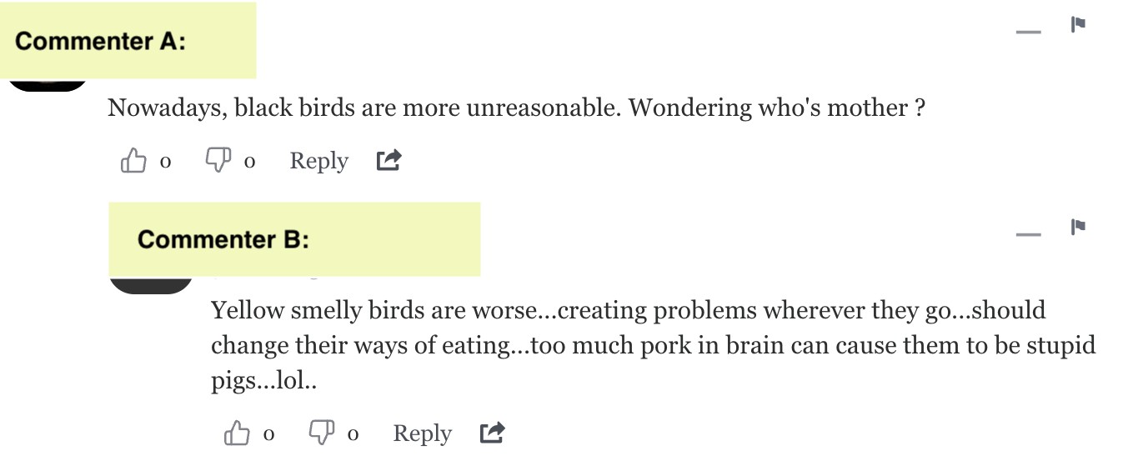

*Figure 2: screenshot from comment section of the article on STOMP*

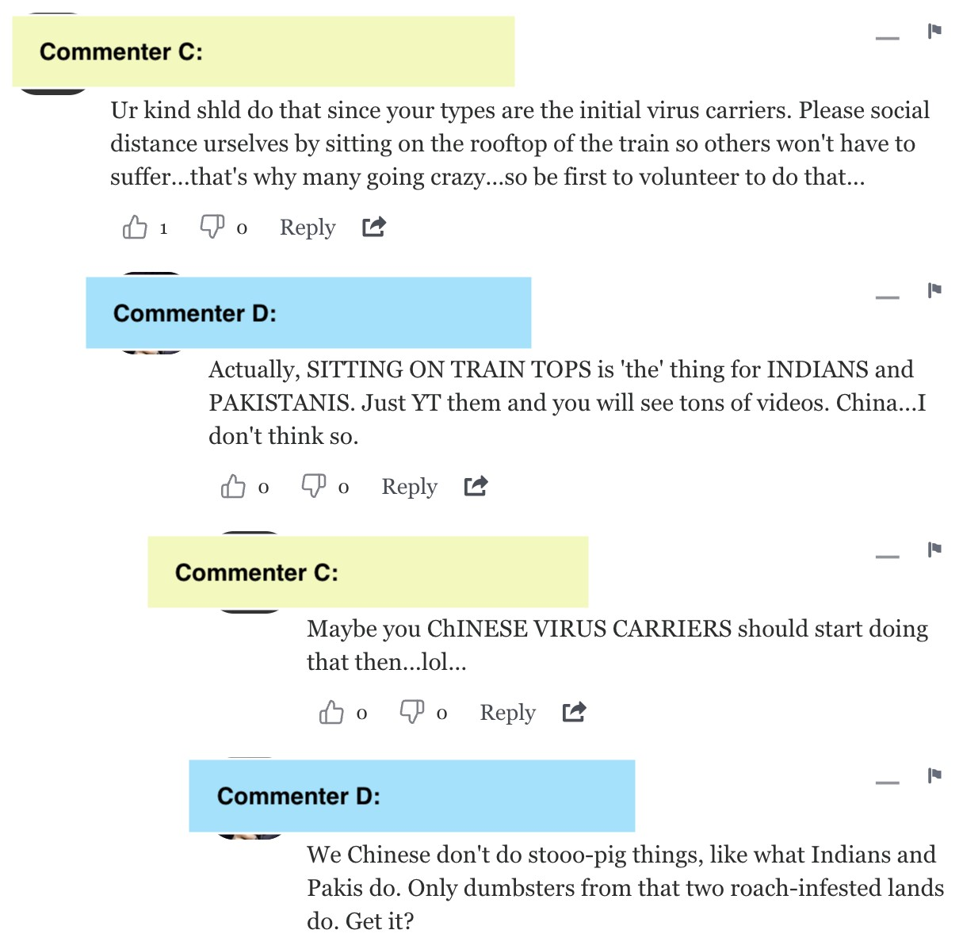

*Figure 3: screenshot from comment section of the article on STOMP*

As seen in Figures 2 and 3, these comments are racialized and demonstrate extreme bias towards certain racial groups. For instance, the comment “black birds” is used to address the Indian woman, with “black” denoting the skin tone of an Indian. Addressing her as “black birds” dehumanized her based on her ethnicity, indicating a racialized perception towards the Indians. “Yellow smelly birds” refers to the Chinese woman, which associates Chinese with a bad body sensation. In addition, the term “yellow” is widely recognized as the racialized term used to address Asians in Western culture, making comment B an extremely racist sentiment (Keevak, 2019). During the outbreak of COVID-19, there were heavy accusations against the Chinese population for carrying and spreading the virus to and in Singapore, “virus carrier” emerged as a result and became a derogatory term used against the Chinese.

These comments also make generalizations and sweeping statements such as “sitting on train top” is done by Indians and Pakistanis, referring to India and Pakistan as “roach-infested lands,” and people from these countries are “dumpsters.” These terms are highly offensive and highlight the racially biased perception commenter D holds towards Indians and Pakistanis.

# Analysis and Interpretation

This case study is a prime example of how acts of lateral surveillance work to reinforce, as well as reproduce, existing racial stereotypes in Singapore. Before analyzing the implications of racial stereotypes that exist within lateral surveillance, it is important first to recognize how social norms and boundaries are maintained through these practices. The comment section within this STOMP article allows us to see how the publication and sensationalization of the act of deviance work to reinforce social norms of mindfulness in public spaces.

Emile Durkheim’s theory of control and deviance provides a useful framework for comprehending the function that deviance serves in society. Durkheim argues that crime and deviance are normal aspects of every society (Durkheim, 2008, pg. 86). He states that “crime… is bound up with fundamental conditions of all social life” (Durkheim, pg.88). When crime exists, shared societal reactions to the act of violence and deviance arise, allowing for the development of collective moral consciousness. We learn what is right and wrong from the crimes themselves, accompanied by “appropriate” punishments. Moral boundaries are created and reinforced. Thus, the function of crime plays an essential role in societies by regulating social norms, collective sentiment, and moral boundaries (Durkheim, pg.88). Although it is important to note, the collective solidarity afforded through crime comes at the expense of “the deviant” (Durkheim, pg.88). When the punishment of the criminal, a socially constructed label, transforms into a spectacle aimed at reinforcing commitment to social norms, it leads to detrimental consequences for those who are labeled “deviant.”

The case study illustrates how applying Durkheim’s theory to instances of deviance, such as selfishly occupying two seats on the MRT, showcases the role of social regulation in shaping and reinforcing societal boundaries through mechanisms like lateral surveillance. Though occupying two seats on a crowded MRT might not warrant arrest, it exemplifies how acts of deviance regulate social norms. This behavior, accompanied by public shaming through lateral surveillance, subtly conveys a message to readers: be mindful in public spaces and avoid taking multiple seats. In addition to exposing these instances of deviance on one of the largest platforms in Singapore, the comment section functions as a space for public moral criticism, which allows online users to partake in denouncing not only the deviant behavior but also the individual responsible (Billingham & Parr, 2017, p.1000). These practices of lateral surveillance further reinforce social norms and their consequences. By the end of the brief article, readers understand the wrongness of such behaviors in public spaces, fostering a sense of social solidarity.

Durkheim’s theory allows us to understand how the practice of lateral surveillance online produces and reproduces social solidarity. Yet, the outcome of social solidarity comes at the expense of further marginalizing minority groups. The comment section contains derogatory stereotypes targeting both Indian and Chinese women. However, these stereotypes hold greater harm for minority groups due to their reinforcement of existing societal biases within a structure that already marginalizes them.

Applying Cesare Lombroso’s theory within positivist criminology underscores the harmful connotations and implications of the racialized sentiments towards the minoritized party found within the case studies. Lombroso, “created a prototype of the criminal body based on specimens of ‘atavism’ from the ‘native’ peoples of the global south” (Carrington & Hogg, pg.192). His theory centered around “images and assumptions regarding the traits held to be innate to non-white races – impulsiveness, lack of self-control, emotionalism, violent propensities, immortality, idleness, and so on…” (Carrington & Hogg, pg.186). Often these negative traits were placed on younger men from lower socioeconomic backgrounds and racial and ethnic minority groups (Carrington & Hogg, pg.186). Specifically, Lombroso’s theory implies that the traits of criminals he studied were innate. Thus, positivist criminology creates alluring fiction that is embedded in a discourse that links race, class, and age to criminality (Carrington&Hogg, pg.192). The core of positivist criminology justifies how certain marginalized individuals have a greater inclination towards crime while completely disregarding systemic and structural factors at play.

Despite Lombroso’s positivist lens being outdated, the rhetoric of the atavist criminal still presents itself in the language used to criminalize and stigmatize ethnic minorities in relation to crime and deviance. Drawing from the case study, the criticism and derogatory comments about the Indian women in the altercation not only perpetuate harmful stereotypes but also contribute to the marginalization and discrimination faced by minority groups in society. A comment that stated, “They, [Indians], deserved to travel on the roof-tops of the train,” sparked a heated argument between Commenter C, presumed to be an Indian Singaporean, and Commenter D, presumed to be a Chinese Singaporean (Daley, 2023). Focusing on the comments made by Commenter C, they state, “Actually, SITTING ON TRAIN TOPS is ‘the’ thing for INDIANS and PAKISTANIS” and “We Chinese don't do stoo-pig things, like what Indians and Pakistanis do” (Daley, 2023).

While the argument was heated on both sides, the basis of Commenter D's remarks directed towards Indians and Pakistanis, two minority groups, is not only grounded in positive criminology but also reinstates the racial hierarchy in Singapore. Firstly, due to the presumed ethnicity of Commenter D being Chinese Singaporean, they speak from a place of privilege in contrast to Commenter C. This dynamic further reinforces Chinese hegemony in Singaporean society, as “Chinese Singaporeans…are in the majority and dominate the political, economic and cultural spheres” (Velayutham, pg.470). Secondly, Commenter D’s rhetoric is rooted in a narrative that draws on Lombroso’s positivist criminology. For instance, within their comments mentioned above, the underlying assumption Commenter D makes regarding Indians and Pakistanis sitting on train tops and doing “stooo-pig” things is fixed within notions of these minoritized individuals coming from primitive worlds. Similar to Lombroso’s rhetoric of identifying criminals based on phenotype and labeling stereotypes, these patterns also occur within the framework of criticizing deviant minorities.

While the focus of this case study may be regarded as harmless online banter, the readily accepted stereotypes ingrained in the social milieu of Singapore communicate that discriminatory attitudes towards certain minority groups persist, further reinforcing societal inequalities. Although Singapore’s narrative of multiracial harmony assumes the idea of meritocracy and fairness, it fails to acknowledge systemic or structural impediments that may prevent minority groups from accessing particular pathways to social mobility (Velayutham, pg.459). Therefore, when the practice of lateral surveillance and public moral criticism employs negative stereotypes to criminalize the already marginalized deviant, it reproduces systems of power that privilege the majority.

# Conclusion

In conclusion, this paper attempts to highlight the consequences of prevalent lateral surveillance, along with public moral criticism, in Singapore and how it can exacerbate underlying racial tensions in a seemingly multiracial country. Although the case study presented is not comprehensive and extensive enough to generalize this phenomenon, it can still shed light on how racialized stereotypes and their harms are perpetuated through the acts of lateral surveillance. Moreover, despite the focus being on the interaction between race and lateral surveillance, we believe that other social dimensions–like class, gender, and religion–can be further explored in shaping the sphere of lateral surveillance in Singapore. This essay’s examination of how the racialization of lateral surveillance has the function of reinforcing minority racial stereotypes which can contribute towards a more positivist approach towards

lateral surveillance.

**Works Cited**

*About Us*. Stomp. (2016, July 27). https://stomp.straitstimes.com/about-us

Albrechtslund, A. (2008). *Online social networking as participatory surveillance*. *First Monday*,

13(3). <https://doi.org/10.5210/fm.v13i3.2142>

Andrejevic M. (2004). *The work of watching one another: lateral surveillance, risk, and governance*. *Surveillance & Society*, 2(4), 479–497

Billingham, P., & Parr, T. (2020). *Enforcing social norms: The morality of public shaming.*

*European Journal of Philosophy*, 28(4), 997–1016. <https://doi.org/10.1111/ejop.1254>

Carrington, K., & Hogg, R. (2017). Deconstructing Criminology’s Origin Stories. *Asian Journal of Criminology*, *12*(3), 181–198.

Chong, T. T. L., & Zaini, K. (2022). Race and Racism in Singapore. In *Southeast Asian Affairs 2022* (pp. 324–342). <https://doi.org/10.1355/9789815011036-020>

Daley, F. (2023, December 20). Woman confronts elderly commuter for taking up two seats on

MRT train. *Stomp*.

https://stomp.straitstimes.com/singapore-seen/woman-confronts-elderly-commuter-for-ta king-up-two-seats-on-mrt-train

*Demographics of singapore in 2023 - Growth Drivers & Regional Outlook*. OOSGA. (2023,

October 30). https://oosga.com/demographics/sgp/#:~:text=Singapore%20is%20a%20densely%20pop ulated,%2C%20and%20Indians%20(9%25).

Durkheim, E. (2008). The normal and the pathological. In R. Heiner (Ed.), *Deviance across cultures.* (pp. 3–7). Oxford University Press.

Jiow, H. J., & Morales, S. (2015). Lateral surveillance in Singapore. *Surveillance &amp; Society*,

*13*(3/4), 327–337. <https://doi.org/10.24908/ss.v13i3/4.5320>

Kamaludeen, M. N. (2018). ‘Policing the poor’ and ‘poor policing’ in a global city. *Journal of*

*Poverty*, *22*(3), 209–227. https://doi.org/10.1080/10875549.2017.1419526

Kathiravelu, L. (2021, May 18). *Rethinking race: Beyond the Cmio categorisations*. New

Naratif. <https://newnaratif.com/rethinking-race-beyond-the-cmio-categorisations>

Keevak, M. (2019, February 3). *Opinion: The Chinese were white, until white men called them yellow*. South China Morning Post.

[https://www.scmp.com/week-asia/opinion/article/2184754/chinese-were-white-until-whit e-men-called-them-yellow](https://www.scmp.com/week-asia/opinion/article/2184754/chinese-were-white-until-white-men-called-them-yellow)

Mathews, M. (2014). Indicators of Racial and Religious Harmony: An IPS-OnePeople.sg Study. Singapore: Institute of Policy Studies.

Mothership. (n.d.). News from Singapore, Asia and around the world. Mothership.SG. Retrieved

March 15, 2024, from <https://mothership.sg/about-us/>

Puthucheary, J. (2019, October 15). *Where does singapore stand on race relations? | regardless of race | full episode*. YouTube. <https://www.youtube.com/watch?v=a8fZaujJijo>.

*Research help: Anti-racism resources: What does racism look like? stereotypes & tokenism*.

What Does Racism Look Like? Stereotypes & Tokenism - Anti-racism Resources -

Research Help at Fitchburg State University. (2023, March 15). https://fitchburgstate.libguides.com/c.php?g=1046516&p=7611618

Tan, C. (2015, March 23). *Lee Kuan Yew leaves a legacy of authoritarian pragmatism*. The

Guardian. https://www.theguardian.com/world/2015/mar/23/lee-kuan-yews-legacy-of-authoritarianpragmatism-will-serve-singapore-well

Vasu, N. (2007). *Social Resilience in Singapore: Reflections from the London bombings*. Select

Pub.

Velayutham, S. (2016). Races without racism?: Everyday Race Relations in Singapore. *Identities*,

*24*(4), 455–473. <https://doi.org/10.1080/1070289x.2016.1200050>